Parts of a Flower Notes

Flower:

A Perfect Flower:

An Imperfect Flower:

The Parts of the Flower
Stamen:
Filament:
Anther:

Pistil:
Stigma:
Style:

Ovary:

Ovule:

Petal:

How do flowers attract pollinators?
What is another way of pollination?

Sepal:

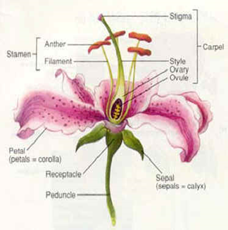

Word Bank
Stamen
Anther
Pistil
Ovary
Stigma
Ovule
Petal
Filament
Style
Sepal
.

